# dreams, SCREAMS & washing machines

**Pauline Deakin**

William Cornelius Harris Publishing

In collaboration

With

London Poetry Books

Supporting Mental Health in Performing Arts

ISBN 978-1-911232-23-0

Copyright © Pauline Deakin 2019

All rights reserved

First Edition

20 Spendlow Drive ME5 9JT

London Poetry Books

**Dedication**

Thank you to my family for encouragement and to the person who let me share some of the difficult stuff as well as the love.

**Acknowledgements**

Artwork inside the book is credited to Mark Smoker. His work can be found at www.facebook.com/marksmokerart

Edited by Amy Deakin.

Cover designed by Ian Lynch. Inkandsocial.co.uk

Photograph on back cover by Alison Wonderland www.alisonwonderland.co.uk

Extract only

Contents

DREAMS 5

You Are Not a Poet 7

Ice 8

Dreams, Screams and Washing Machines 9

Barking 10

Nature Week 12

Overthinking 13

Northern Line 14

Romantic Fiction 15

Shed of Your Dreams 16

SCREAMS 17

This 18

Chair 19

Hidden 21

Your House 22

War 23

Night 24

WASHING MACHINES 25

You 26

First Train Ride 27

Streets Apart 28

Neutral 29

Tea 30

Old Gig Goer 32

Old Men Running 34

There and Back Again 35

To Do 37

Tweets 38

**DREAMS**

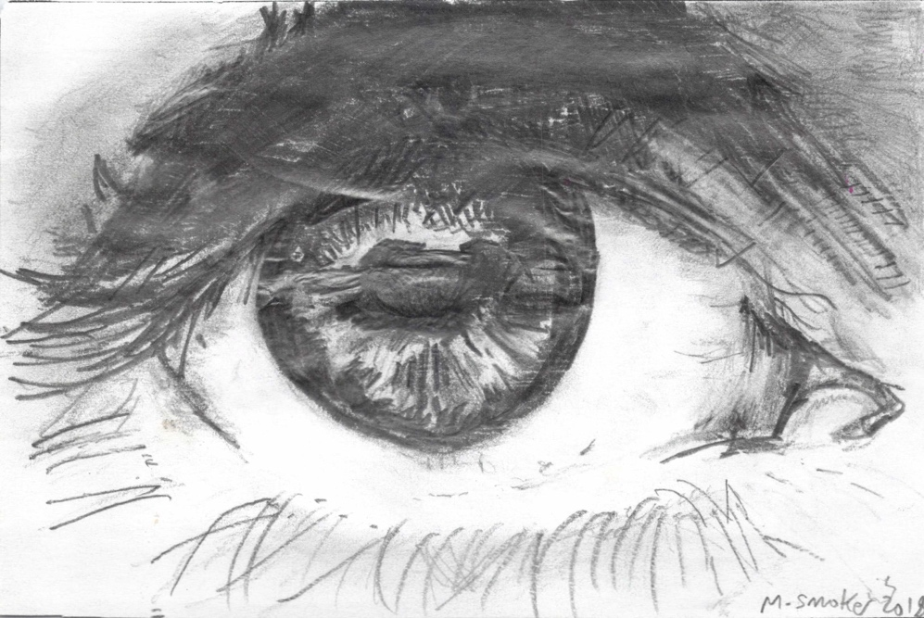

**You Are Not a Poet**

You are not a poet  
Because your poems don’t rhyme  
Or scan  
Or use long words.  
  
You are not a poet  
Because your poems are open.  
Make sense.  
Do not hide.  
  
You are not a poet  
Because nothing much happens  
Except  
They make me cry.  
  
They are poets  
Because someone decided  
High up  
In a tower.  
  
So you are not a poet  
And you’d better accept it.  
Stop right now!  
Why are you still writing?

**Ice**

The white hair soft as cotton wool.

Ice blue eyes. Hard.

You haunt my dreams.

Stuff of fairy tales.

Did I build you up

Into something I created?

Invading my space.

The witch, stepmother, ice queen

Tearing the skin and throwing it to the dogs.

Or are you the reflection of another?

I catch a glimpse of her from time to time

Reflected in the broken glass

As I glance into the eyes

Of the one who loved me

Once upon a time.

**Dreams, Screams and Washing Machines**

Last night I had my dream,

The one where I’m bathing the baby.

During a momentary lapse of concentration

I went to answer the phone.

When I returned

She was still swimming happily

Face down.

Before I had the baby

I used to dream about my cats.

I accidentally put one in the washing machine

With a pile of clothes.

It was quite a shock

To watch it miaowing silently

Through glass.

These dreams bother me.

(Although I’m very careful when awake).

It’s the way they keep recurring

Like someone nudging me in the ribs

Or standing behind me

Whispering seductively in my ear.

It’s all going to go wrong.

It’s all going to go wrong.

Other Excellent Titles from

London Poetry Books

Twisted and Chewed Shaun Rivers

Morden and other Tourist Destinations Amy Deakin

There is A Tune Cathy Flower

Probably the Secret Police and Other Slices Nick Eisen

And it comes Blowing George E Harris

Arts Square Look& Stare Keith Bray

The Mirrors of Thespis Keith Bray

Pocket Full of Whispers. Keith Bray

Swimming with Endorphins. Fran Isherwood

Ooetry. Wendy Young

Going with the Flow Hababa Hrida

Making it Verse. Hababa Hrida

Rhymes for the Times. Hababa Hrida

Life and Hope Jason Harris

Death Suicide Despair Poetry. Jason Harris

Seven Sin Quin Agathoni

Of The Deep IDF Andrew

The Bird of Morning. IDF Andrew

I’m not here for your,

Entertainment Tara Fleur

Sibling Ribaladries. N& H Sullivan

Dark Matter Amy Smith

Joy Fear and F—k It Ant Smith

Haigha’s Noosphere Canticles Rick Dove

English is a Foreign Language. Alain English

Outside in Musin on life as,

An Autistic Poet. Alain English

In the Name of the Flesh. Ernesto Sarezale

Pathways Anne Gaelan

SmackDown Shakespeare,

Super Sunday. Mickey Bee

When London Finally Gave in,

And Started To Love. Ernie Burns

Product Details

**ISBN 9781911232230**

**Copyright Paulin Deakin (Standard Copyright Licence)**

**Edition First Edition**

**Publisher William Cornelius Harris Publishing**

**Published 31 May 2019**

**Language English**

**Pages 40**

**Binding Perfect-bound Paperback**

**Interior Ink Black & white**

**Weight 0.11 kg**

**Dimensions (centimetres) 14.81 wide x 20.98 tall**

**www.londonpoetrybooks.com**